FACE RECOGNITION USING OPENCV WITH PYTHON

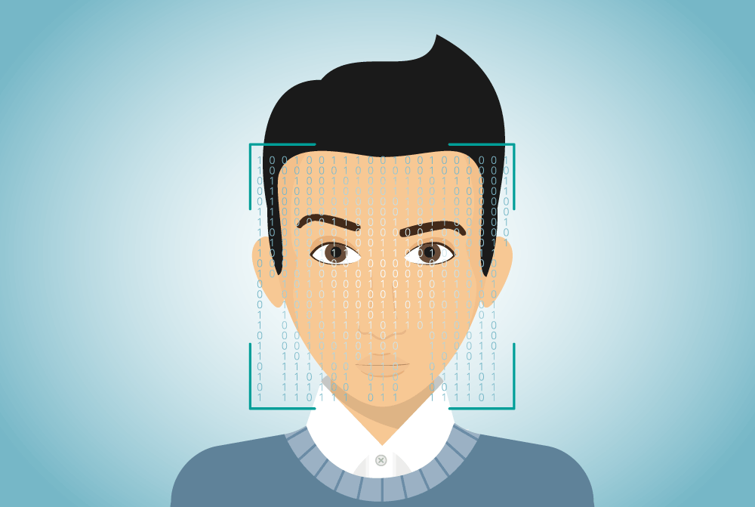

PROJECT GROUP
1. Amol Chauogul
2. Preeam Chinde
3.Praveen Kumbar

SYNOPSIS CONTENT

- Introduction

- Scope of the project

- Reason behind making a project

- Tools to be used

- Complete structure of the project

1.Working methodology

2.Block diagram

3.Details about the Hardware & Software

4.Testing Plane

- Advantages and Disadvantages

- Application

- Conclusion

- Reference

Introduction:
Face Recognition is a technology in computer vision. In Face recognition / detection we locate and visualize the human faces in any digital image.
It is a subdomain of Object Detection, where we try to observe the instance of semantic objects. These objects are of particular class such as animals, cars, humans, etc. Face Detection technology has importance in many fields like marketing and security.

Cascade Classifiers and Haar Features:
It is a machine learning algorithm where we train a cascade function with tons of images. These images are in two categories: positive images containing the target object and negative images not containing the target object.
There are different types of cascade classifiers according to different target objects. In our project, we will use a classifier that considers the human face to recognize it as the target object.

Scope of Project:

- Futuristic fantasy in our minds that a time will come when software would be used to recognize people by their faces. A time when our faces will be our ID cards. With advent of facial recognition technology,

- Today, along with drones, AI and IoT, facial recognition technology is also defining our millennium. Facial recognition is a biometric technology used for authentication and examination of individuals by correlating the facial features from an image with the stored facial database. Face Recognition is one of the most popular applications of image analysis software and no more considered as a subject of science fiction. Earlier, this technology was only used for security and surveillance purposes, but it has safely transitioned to the real world in recent times. Today, companies are pitching facial recognition software as the future of everything from retail to policing.

Reason behind making a project:

Face recognition, as one of the most successful applications of image analysis, systems have been developed for face detection and tracking, reliable face recognition still offers a great challenge to computer vision and pattern recognition researchers. There are several reasons for recent increased interest in face recognition,including rising public concern for security, the need for identity verification in the digital world, face analysis and modelling techniques in multimedia data management and computer entertainment.

Tools to be Used:

1. PYTHON

2. OPENCV

1.PYTHON:
Python is a general purpose and high level programming language. You can use Python for developing desktop GUI applications, websites and web applications,allows you to focus on core functionality of the application by taking care of common programming tasks. The simple syntax rules of the programming language further makes it easier for you to keep the code base readable and application maintainable.

2.OPENCV:
OpenCV-Python makes use of Numpy, which is a highly optimized library for numerical operations with a MATLAB-style syntax. All the OpenCV array structures are converted to and from Numpy arrays. This also makes it easier to integrate with other libraries that use Numpy such as SciPy and Matplotlib.

3.OPENCV WITH PYTHON:
OpenCV is the most popular library for computer vision. Originally written in C/C++, it now provides bindings for Python,OpenCV cascade breaks the problem of detecting faces into multiple stages. For each block, it does a very rough and quick test

Complete structure of the Project:

Working Methodology:

Step 1: Face Detection
To begin, the camera will detect and recognize a face, either alone or in a crowd. The face is best detected when the person is looking directly at the camera. The technological advancements have enabled slight variations from this to work as well.

Step 2: Face Analysis
Next, a photo of the face is captured and analyzed. Most facial recognition relies on 2D images rather than 3D because it can more conveniently match a 2D photo with public photos or those in a database. Distinguishable landmarks or nodal points make up each face. Each human face has 80 nodal points. Facial recognition software will analyze the nodal points such as the distance between your eyes or the shape of your cheekbones.

Step 3: Converting An Image to Data
The analysis of your face is then turned into a mathematical formula. These facial features become numbers in a code. This numerical code is called a faceprint. Similar to the unique structure of a thumbprint, each person has their own faceprint.

Step 4: Finding a Match
Your code is then compared against a database of other faceprints. This database has photos with identification that can be compared.

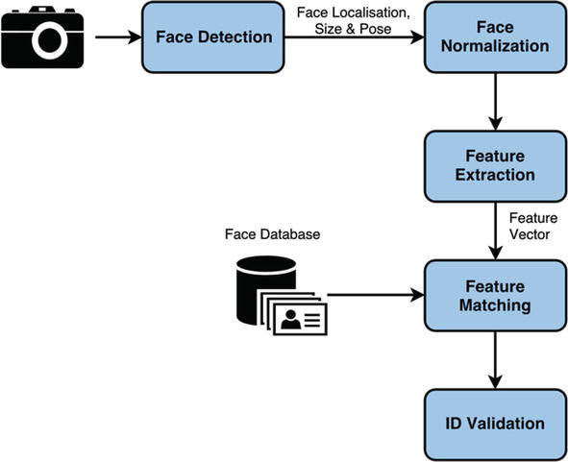
Block Diagram:

block diagram 1

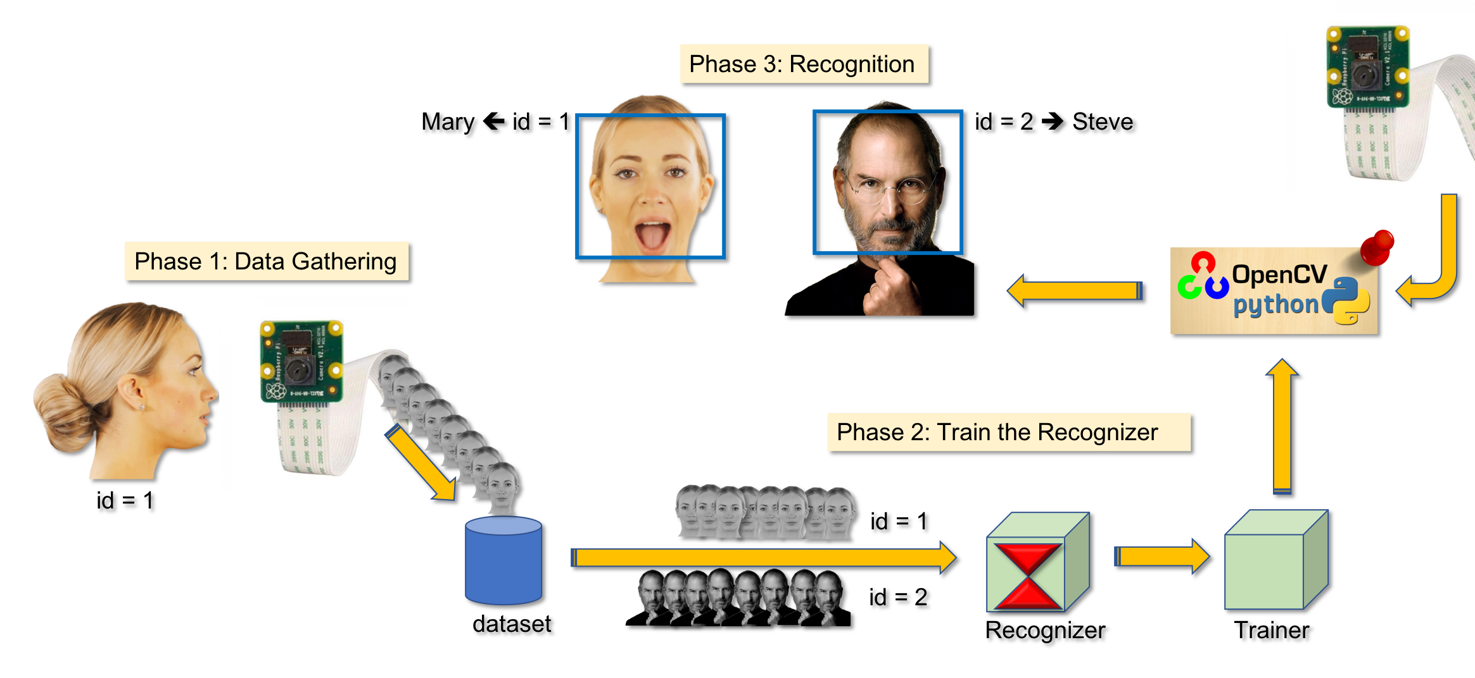
block diagram 2

Detail about Hardware and Software:
Now that you know the potential applications you can build with face detection techniques, let’s see how we can implement this using the open source tools available to us. That’s the advantage we have with our community – the willingness to share and open source code is unparalleled across any industry.

For this article specifically, here’s what I have used and recommend using:
- A webcam (Logitech C920) to build a real time face detector on a Lenovo E470 ThinkPad Laptop (Core i5 7th Gen). You can also use your laptop’s in-built camera, or CCTV camera, on any appropriate system for real time video analysis, instead of the setup I am using
- Using a GPU for faster video processing is always a bonus
- On the software side, we have used Ubuntu 18.04 OS with all the prerequisite software installed
Hardware Setup:
- Connect the WebCam and run the command
- you can do is to use any webcam software to check if the webcam is working correctly. You can use “Cheese” in Ubuntu for this.
Software setup:

Install Python
- The code in this article is built using Python version 3.9 Although there are multiple ways to install Python, I would recommend using Anaconda – the most popular Python distribution for data science. Here is a INSTALL ANACONDA in your system.
Install Opencv

Opencv(Open Source Computer Vision) is a library aimed at building computer vision applications. It has numerous pre-written functions for image processing tasks. To install OpenCV, do a pip install of the library:
Install Face-Recognition API:
Install simplest facial recognition API for Python.

Testing plane:
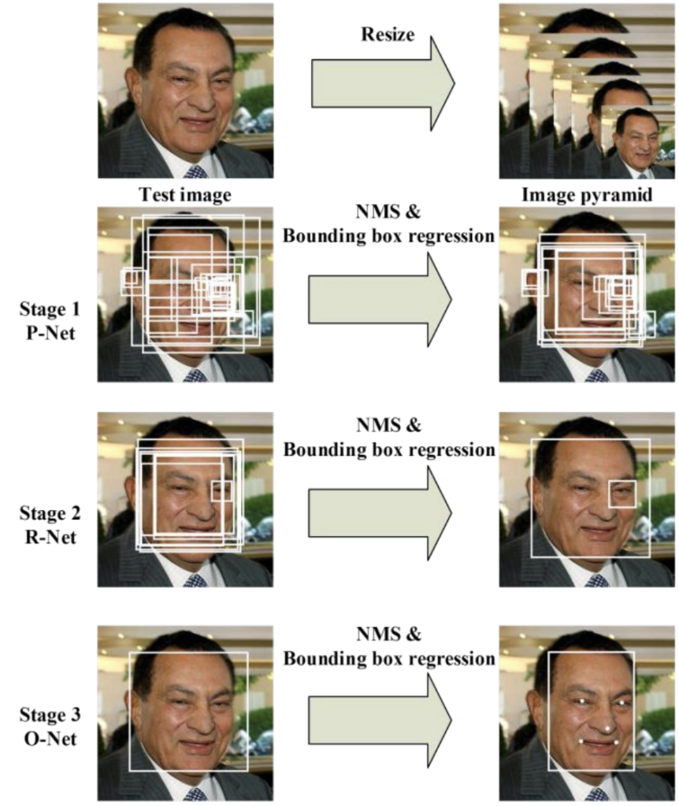
The model is called a multi-task network because each of the three models in the cascade (P-Net, R-Net and O-Net) are trained on three tasks, e.g. make three types of predictions; they are: face classification, bounding box regression, and facial landmark localization.
The three models are not connected directly; instead, outputs of the previous stage are fed as input to the next stage. This allows additional processing to be performed between stages; for example, non-maximum suppression (NMS) is used to filter the candidate bounding boxes proposed by the first-stage P-Net prior to providing them to the second stage R-Net model.

Advantages and Disadvantages:
Advantages:
- High Accuracy
- High Security
- Fully Automated
- low false positive rates

Disadvantages:
- less accuracy to black face
- less accurate to twins face detection

Application:
- Device Security
- Temprature Detection
- Mask Detection
- Using ATM
- Fraud Detection

Conclusion:
In conclusion, in our research, after preprocessing the input face images using some advanced image processing techniques such Contrast Adjustment, Bilateral Filter, Histogram Equalization, so as to have better image features and the same advanced image processing techniques will be applied to the training/template face images plus an image blending method to ensure high quality training/template face images. The preprocessed input face image will be divided into k2 regions, then the LBP code will be calculated for every pixel in a region of the input face image by comparing the center with the surrounding pixel. If the surrounding pixel is greater than or equal to the center pixel, then it is denoted as binary 1, else it is denoted as 0.

Reference:
1. A. J. Colmenarez and T. S. Huang, “Face detection and recognition,” NATO ASI Series F Computer and Systems Sciences, vol. 11, no. 2, pp. 208–218, 1998.View at: Google Scholar
2. L. H. Koh, S. Ranganath, and Y. V. Venkatesh, “An integrated automatic face detection and recognition system,” Pattern Recognition the Journal of the Pattern Recognition Society, vol. 35, no. 6, pp. 1259–1273, 2002.View at: Google Scholar
3. S. Chaudhry and R. Chandra, “Face detection and recognition in an unconstrained environment for mobile visual assistive system,” Applied Soft Computing, vol. 53, pp. 168–180, 2017.View at: Publisher Site | Google Scholar
4. S. Zhang, X. Zhu, Z. Lei, X. Wang, H. Shi, and S. Z. Li, “Detecting face with densely connected face proposal network,” Neurocomputing, vol. 284, pp. 119–127, 2018.View at: Publisher Site | Google Scholar

